**Further conditions on background wells**

Background wells are now tested as:

1. At least 2 wells must be positive, otherwise error message written and plate cannot be processed.
2. Assuming 1 is passed either triplicate must have CV less than 20% or at least one pair must have a CV less than 20% (note it is possible for the triplicate to fail and to have two pairs with CV < 20%. In this case the average of the pair with the lowest CV is taken as the background estimate)
3. If 2 fails, error message is written and plate cannot be processed.

For ‘Totals’ this only needs to be processed for wells F10, F11 and F12. However for the non-total assays, this is repeated for E10, E11 and E12 and in this case:

1. The above points 1 to 3 are tested for the wells F10, F11 and F12 for the standards.
2. If the standard background passes, then the sample wells background E10, E11 and E12 is tested.
3. If these wells fail an error message is written and the plate cannot be processed.
4. If they pass then the plate analysis can proceed.

On failure, the error message is written to the field **Error Message** in table **Tbl_MetaPlate**. There are four error messages.

* All the sample background wells for sample wells are negative
* Two of the sample background wells for sample wells are negative
* Sample background wells too variable : Triplicate and no pair have CV <= 0.2

Additionally if the users does not proceed with the plate due to problems with the standards curve the following error message is written to the table.

* ‘Login Username’ decision based on standards"

All these messages are also written as pop-ups on the screen. For any of the error situations only two options are available to the user:

* Cancel and save nothing
* Save the meta data, with the error message

**Background well meta-data**

The wells used to calculate the background are now also written to field **Background Description** table **Tbl_MetaPlate.** If the standard wells F10,F11 and F12 pass the above, then the description indicates which wells were used and what the average background was, for example:

Standards bckgrd=Av of F10,F11,F12 = 0.11

If the test fail the negative and CV tests, then NA is written to the field.

If the standard wells passed the quality control and it is not a ‘Total’ assay, then the same information is written for the wells E10,E11 and E12, for example

Sample bckgrd=Av of E10,E12 = 0.08

These are then concatenated in the **Background Description** fieldto give for example:

Standards bckgrd=Av of F10,F11,F12 = 0.11 : Sample bckgrd=Av of E10,E12 = 0.08

If the Standards background pass the quality check and the sample wells fail for a non ‘Total’ assay then only the Standards bckgrd information are retained in the **Background Description** field. The **Error Message** field will contain the reason why the sample standards in wells E10, E11 and E12 failed the quality control.

The standards data is also written at the top of the plate report as shown below:

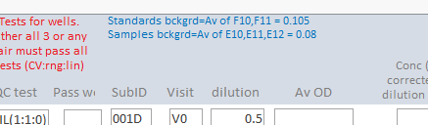

**Appendix I Changes to code**

New function get_background in module DrawGraph.

Inputs:

* typeofy – marks the total assay and uses F10-12 or else E10-12

Outputs:

* p1,p2 and p3 – indicate which backgrounds are selected. If only 2 then p3 = 0
* Function outputs the average value of the background, or four error codes

The four error codes are:

* -999 all three negative
* -111 2 are negative
* -222 no triplicate or pair with CV < 20%

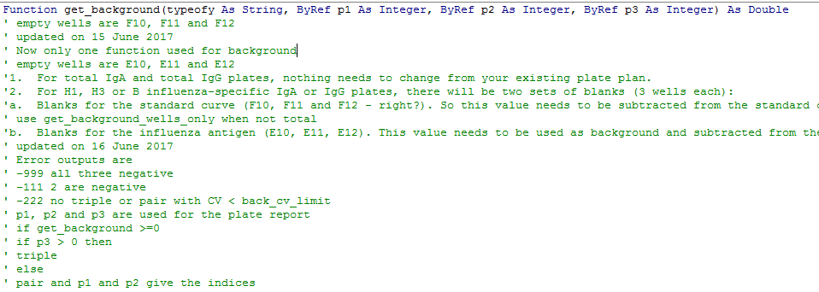

Function calls val_miny, which finds minimum pairwise CV and outputs the pair using p1 and p2

Also calls locate_miny, which if 1 background is negative, finds the pair with minimum CV < 20%, else outputs the error code -222

New global variables defined in form_control



err_out is the error message when the plate cannot be processed

std_back_msg is the description of the standards calculation

These are also stored in **Tbl_MetaPlate** in fields, **Error Message** and **Background Description**

New global constant for the background wells CV in module runFit



The code is fired on the update event of the serial dilution text box for the standards and after the Accept or reject group for the sample wells.

**Additionally the fields below are now reactive.**

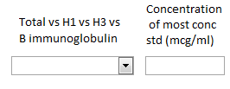

If the Total field is changed during a plate data entry, the background will change so everything must be recalculated, from the standards onwards. If this field is updated after a plate has been processed, the form is re-initialised and users must begin again from the Accept or reject group.

If the concentration is changed then everything from the standards onwards must be re-calculated and the form is nulled and the std dilution factor is nulled to force this process.

The original of this code is in F:\thushan\debug15June2107

